Unix Basics

Exploring Files and Directories, Orientation and Navigation
Objective: To practise ls, cd, pwd, mkdir, rm, and rm -rf by creating, navigating, and cleaning up directories.

- ls – List files in a directory.
- cd – Change directory.
- pwd – Print working directory.
- mkdir – Create a new directory.
- rm -rf – Delete files/directories (use with caution).

Exercise 1.
- Check where you are now. What command did you use?
You should be in your current working directory.
- List its contents. What command did you use?
See which files and folders already exist.
- Create a new directory called ProgSD. What command did you use?
- Move into the new directory. What command did you use?
- Verify your location (Confirm that you are inside ProgSD). What command did you use?
- Create a subdirectory inside ProgSD called ProgSDExam. What command did you use?
- List the contents again (You should now see ProgSDExam). What command did you use?
- List the contents of ProgSD again so that it shows all the permissions, ownership , size, timestamps. What command did you use?
- Navigate into ProgSDExam and confirm. What two commands did you use?
- Go back up one level to ProgSD. What command did you use?
- Remove the ProgSDExam directory (and its contents, if any). What command did you use?
- Create the following directory structure work/docs/reports in one step. What command did you use?
- Navigate into reports, create a text file myfile.txt with a single line. What commands did you use? (Note: You can also create a file inside reports without cd).
- Delete only myfile.txt. What command did you use?
- Delete work/docs/reports.

Copy (cp), move (mv)
The cp (copy) command copies files from any location to another. If the final destination is a directory, copy copies the other files into that directory.
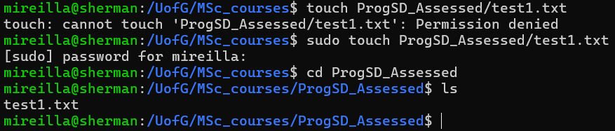
Example 1: The file is copied into the backup_tests directory
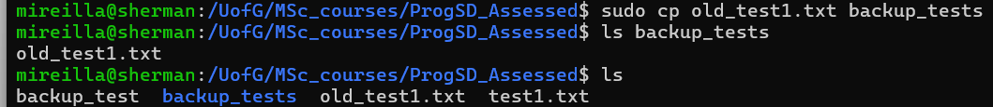
Example 2: A copy of the file old_test1.txt is made and given a different name: old_test50.txt. If a file with the name old_test50.txt already exists, it will be overwritten.
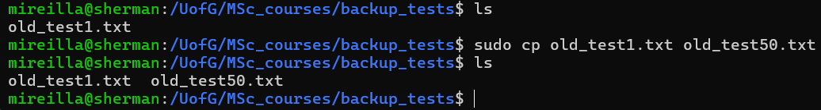
The mv (move) command moves and renames files. It can also be used to rename a file by moving it to a new name in the same directory.
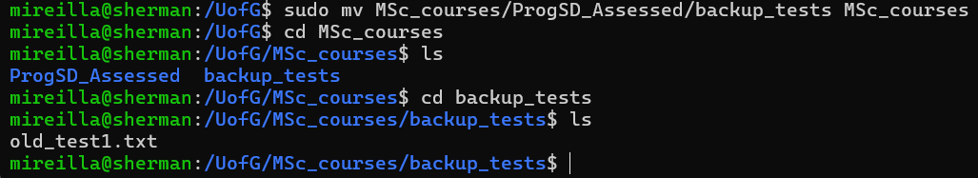

Exercise 2.
- Create a directory structure starting in your current working directory with the following structure:
adventure (main folder)
├── forest/cave
└── village/house
- Navigate into forest/cave and confirm where you are. What two commands did you use?
- List what is inside the cave. What command did you use?
- Write a single command to back up to the adventure folder and confirm your location. What two commands did you use for that single line (Check the practical task that shows how to combine commands in a single line)?
- Create another directory called lake inside adventure. What command did you use?
- List everything in adventure, including their permissions, ownership, size and timestamps. What command did you use?
- List everything in adventure, including hidden files. What command did you use?
- Remove only the lake directory. What command did you use?
- Navigate into village/house and confirm location. What two commands did you use?
- Go back up to adventure and then remove the entire adventure folder and all its contents.

Orientation & Navigation

More shell basics: ls, cd, pwd, man, cp, mv, rm, cat, less, redirection (>, >>, |)
Create a new directory called lab1 and move to that directory.
Inside it, create three files:
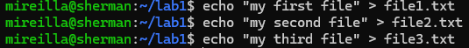
List the files in the directory and save the output to a file list.txt
Append the current working directory to the same file:
View the file with cat and scroll through it with less.
Use man ls to explore the manual page for ls.

Question: Why is redirection useful in log analysis?
Because log files are usually huge, and you do not want to read them all at once on screen. In log analysis, redirection turns raw logs into focused, reusable datasets.
- With redirection (> and >>), you can save command outputs into new files for later analysis.
  - Example: grep "Failed password" /var/log/auth.log > failed.log → collects only failed login attempts.
- With pipes (|), you can chain commands to filter, sort, and count results.
  - Example: cat failed.log | awk '{print $11}' | sort | uniq -c | sort -nr → shows top IPs causing login failures.

